Spring Boot Microservices CI/CD Pipeline with Docker, Jenkins, AWS ECR and EKS

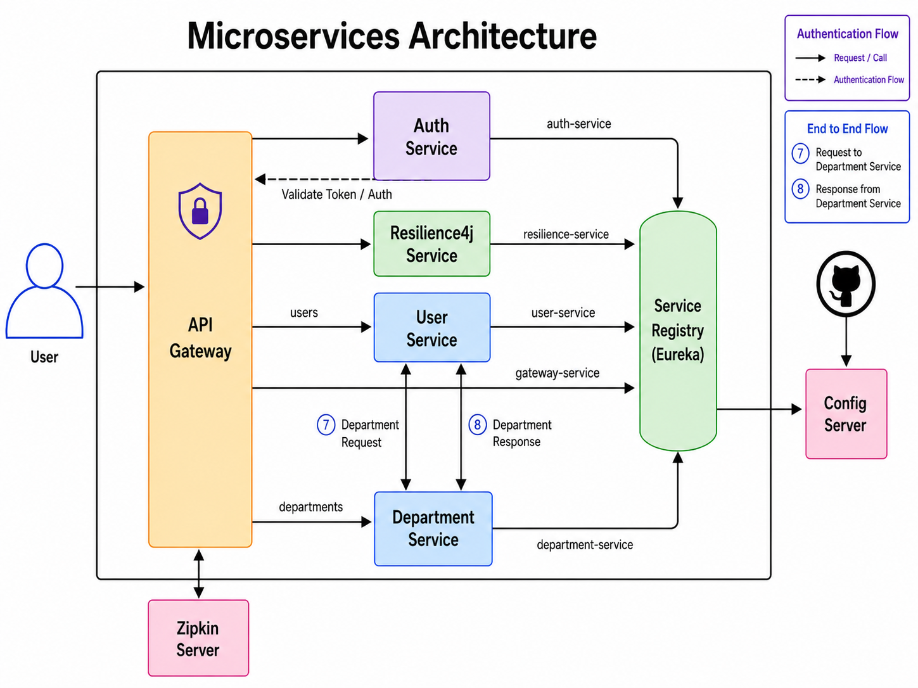

Department data format:
{
"departmentAddress": "456d Park Ave",
"departmentCode": "HR003",
"departmentId": 1,
"departmentName": "Humanes Resources"
}

User Data:

{
"firstName": "John",
"lastName": "Doefygj born",
"email": "john@example.com",
"departmentId": 1
}

Get the Department Data based on department Id in the user information:
{
"user": {
"departmentId": 1,
"email": "john@example.com",
"firstName": "John",
"lastName": "Doe born",
"userId": 1
},
"department": {
"departmentAddress": "456d Park Ave",
"departmentCode": "HR003",
"departmentId": 1,
"departmentName": "Humanes Resources"
}
}

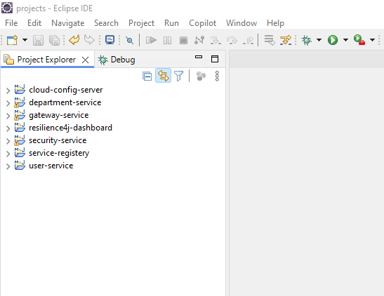

Eureka Server Running : port 8761

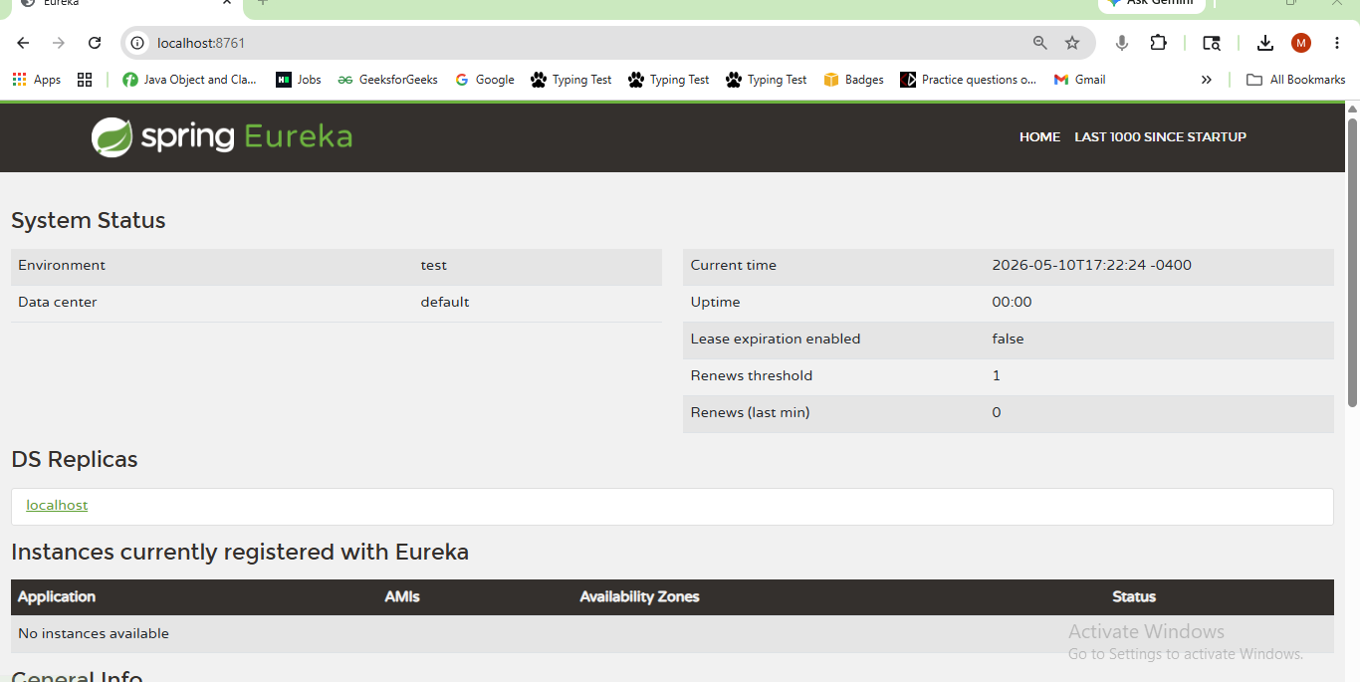

Registered Services:
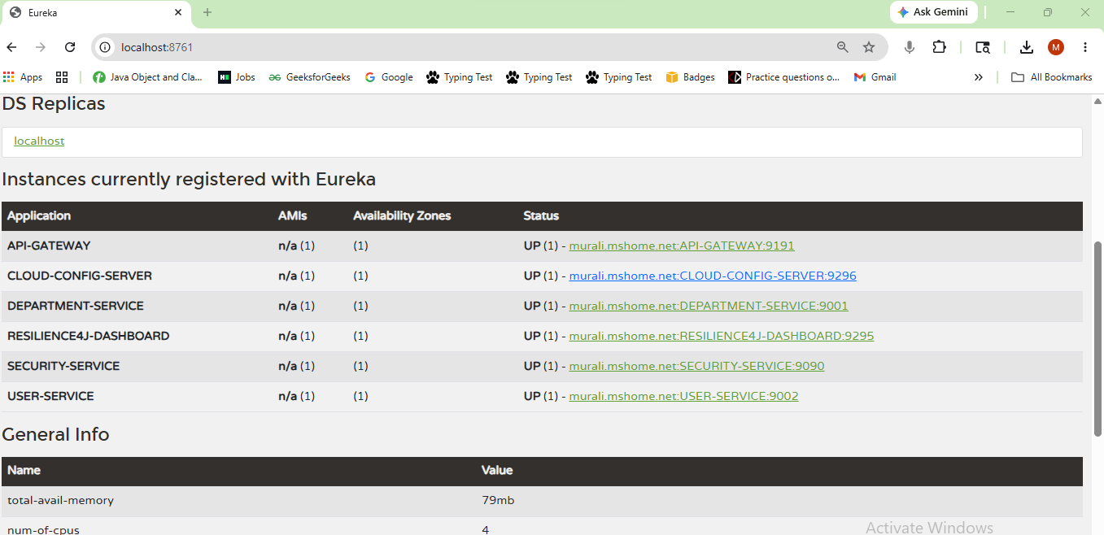

Docker: Zipkin Server Running on port 9411

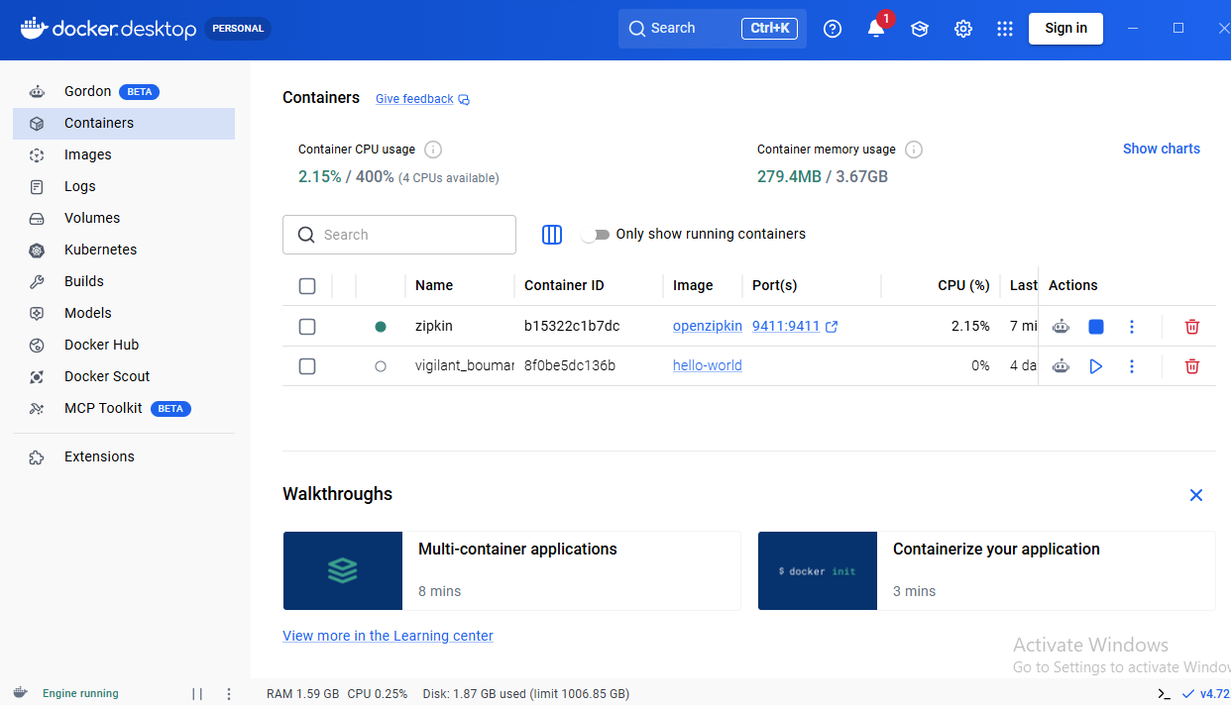

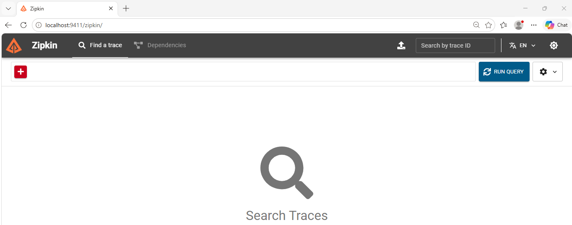

Postman:

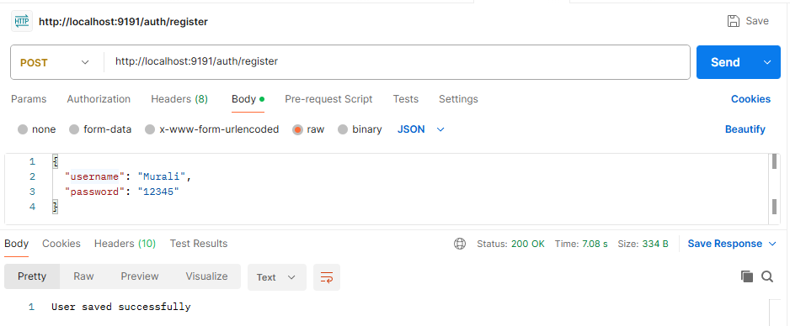

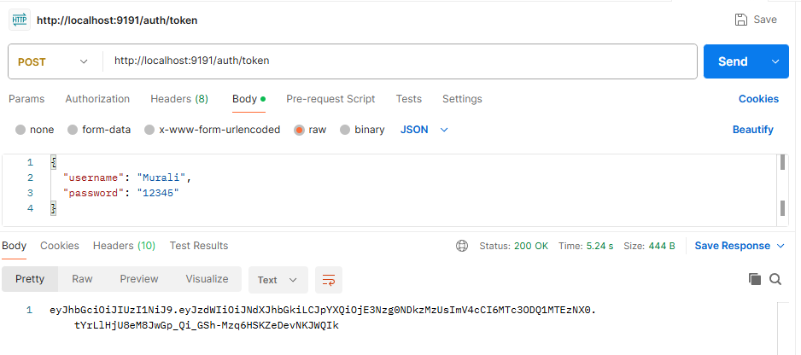

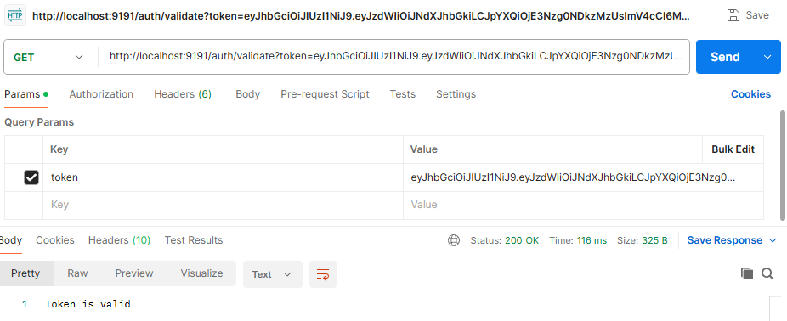

Department Service Call:
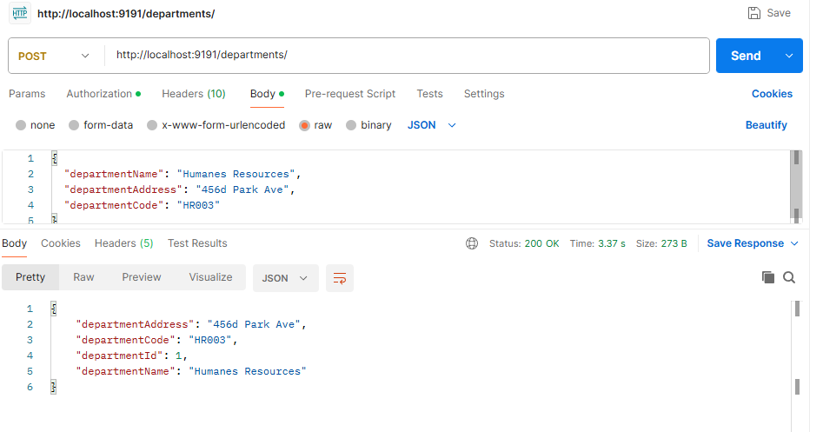

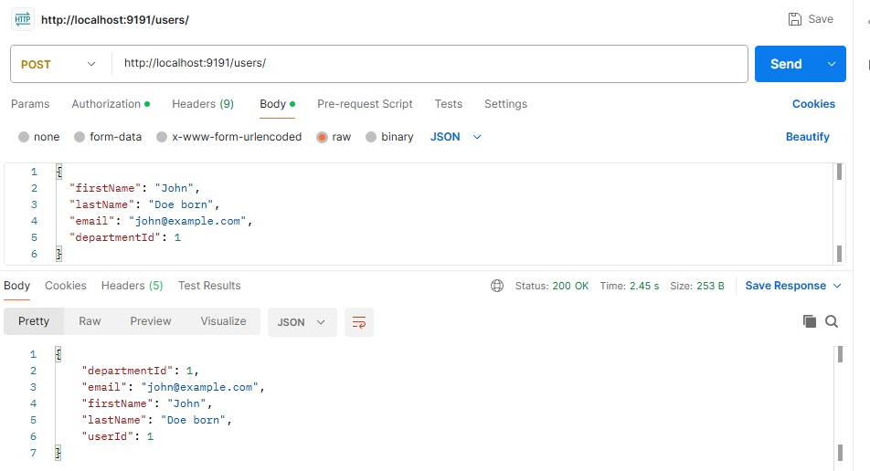

User Service Department Service
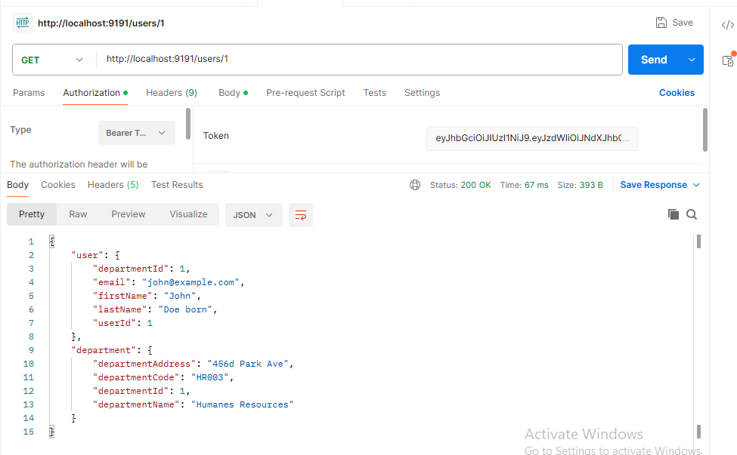

Zipkin Server:

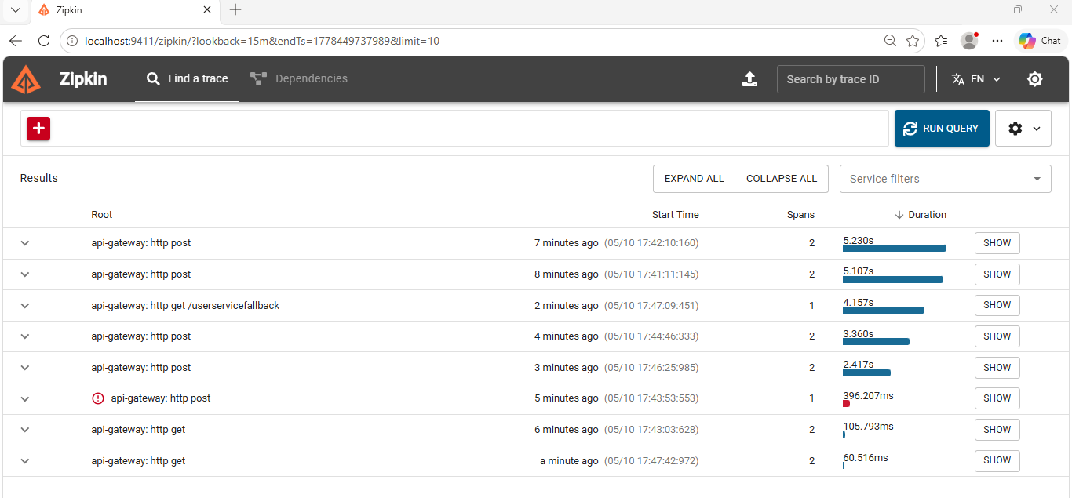

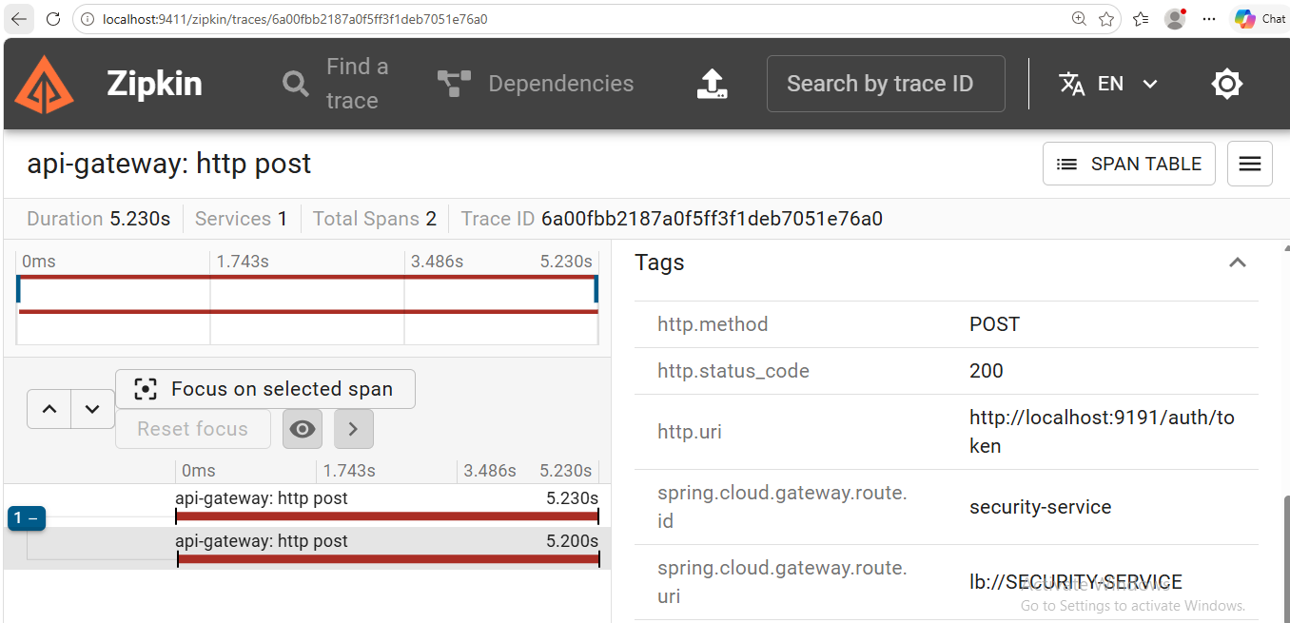

User Get call:
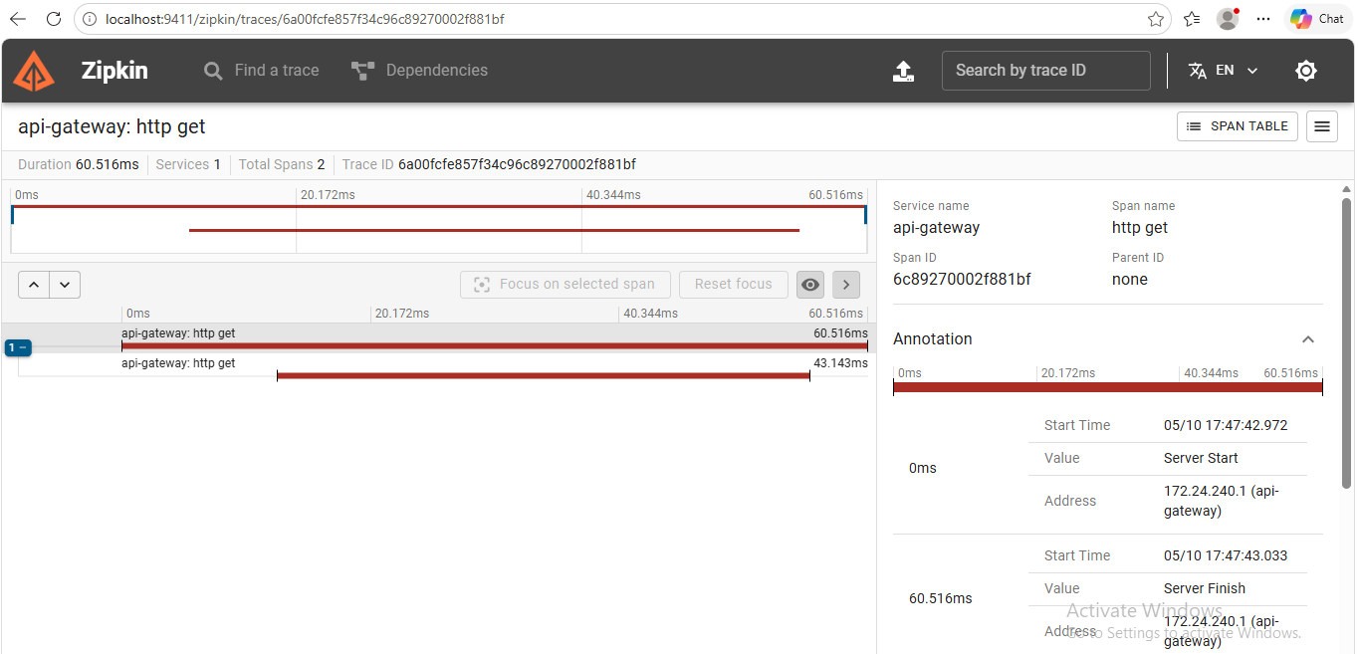

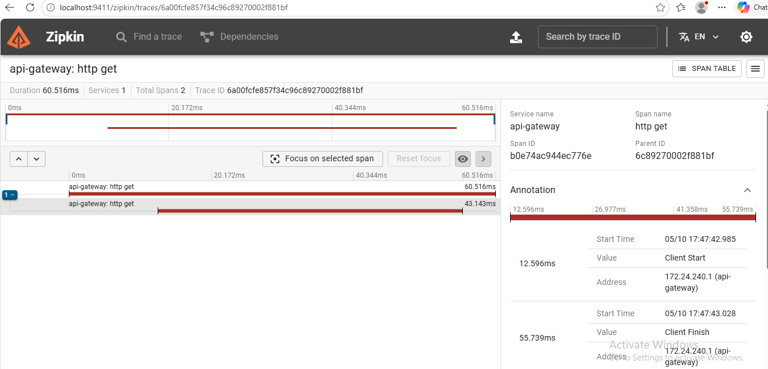

CI/CD pipeline:
---------------------------------------------------------------------------------------------

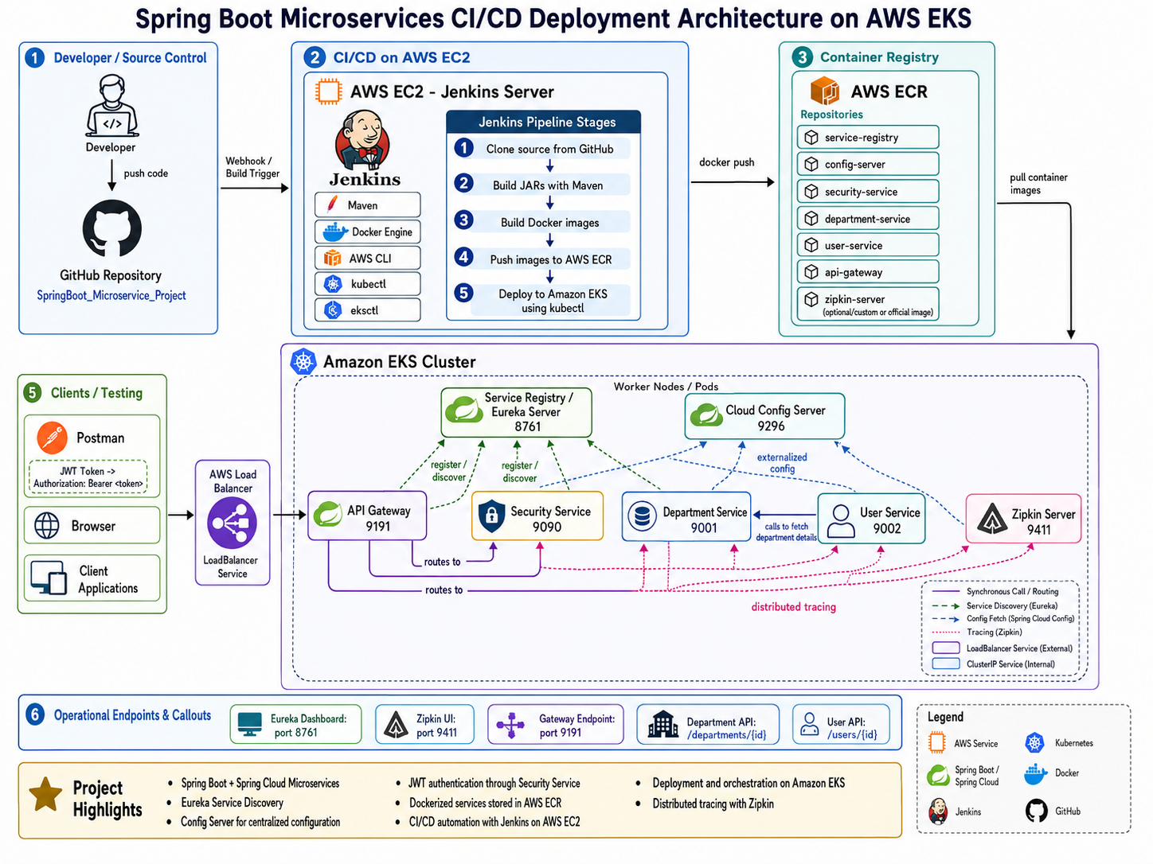

AWS:

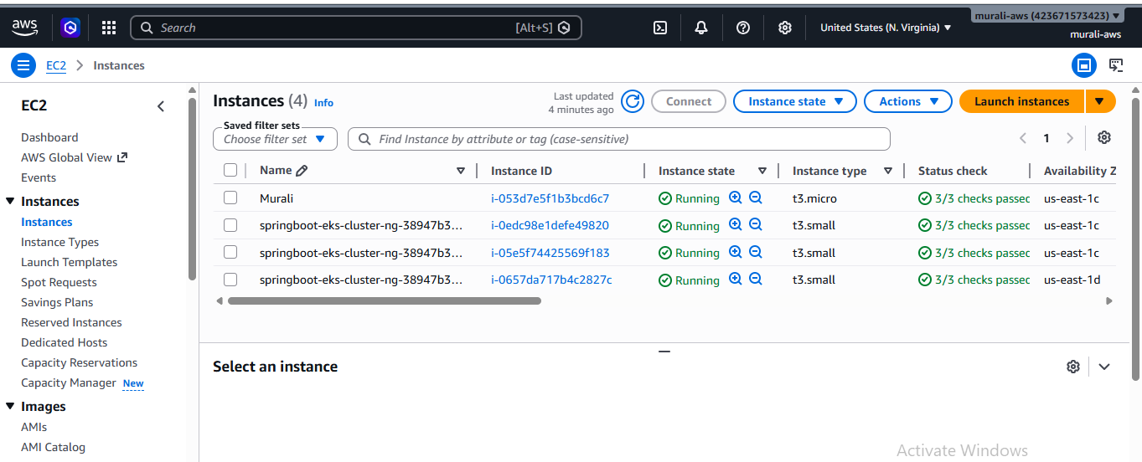
Git Hub:

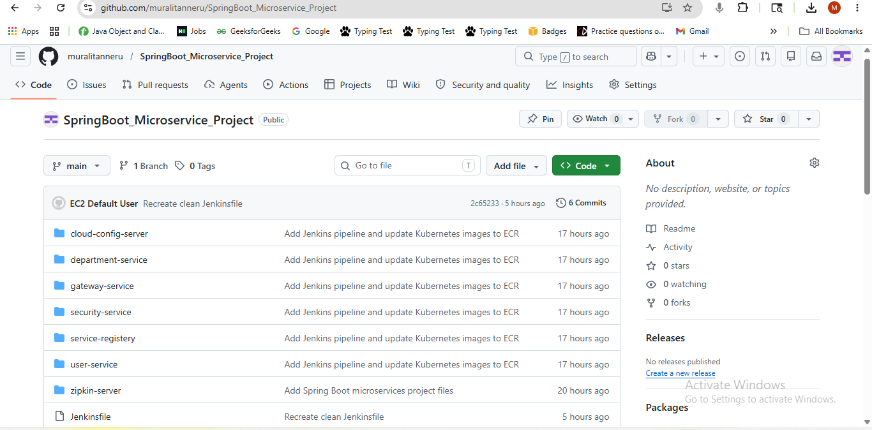

Jenkins pipeline:

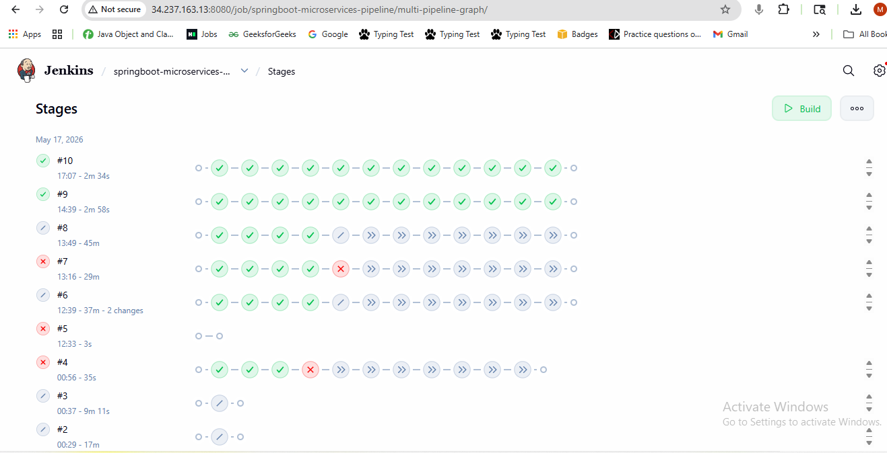

Postman:

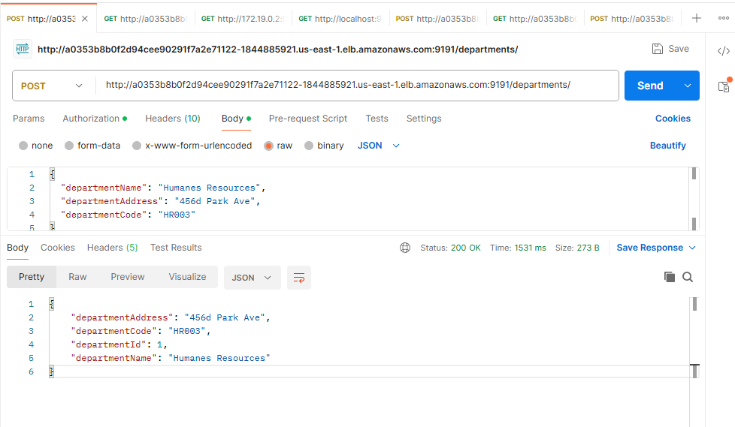

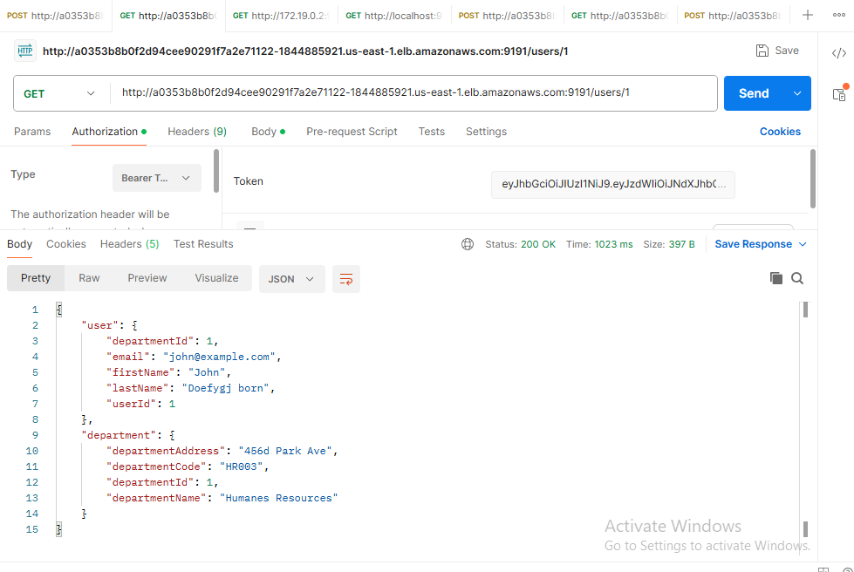

Zipkin Server:

